**Assignment – 9**

**Problem Statement:**

**Deploy a project from GitHub on EC2.**

1. First, upload project repository to Github.

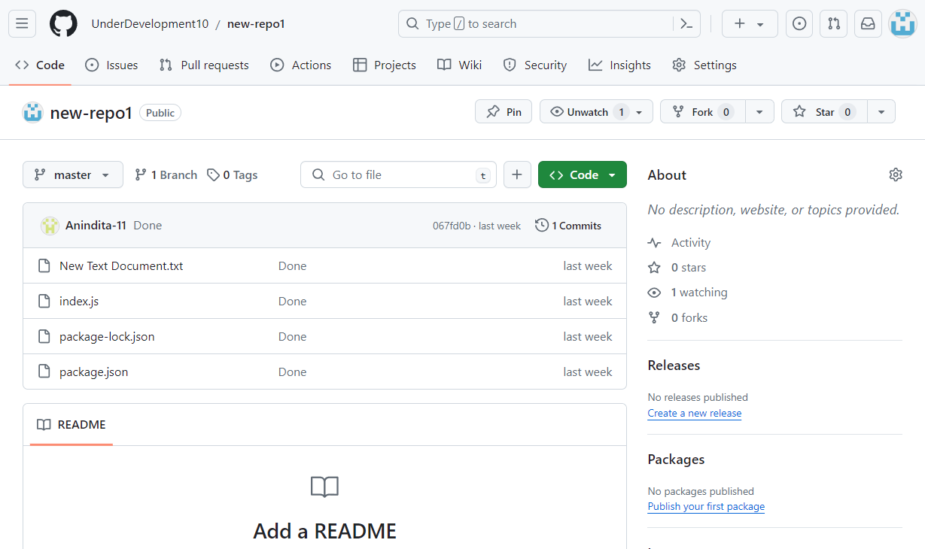

1. Open EC2 and click on Launch Instance.A screenshot of a computer

   Description automatically generated
2. Give the name of server and select Ubuntu application and OS image inside Quick Start.

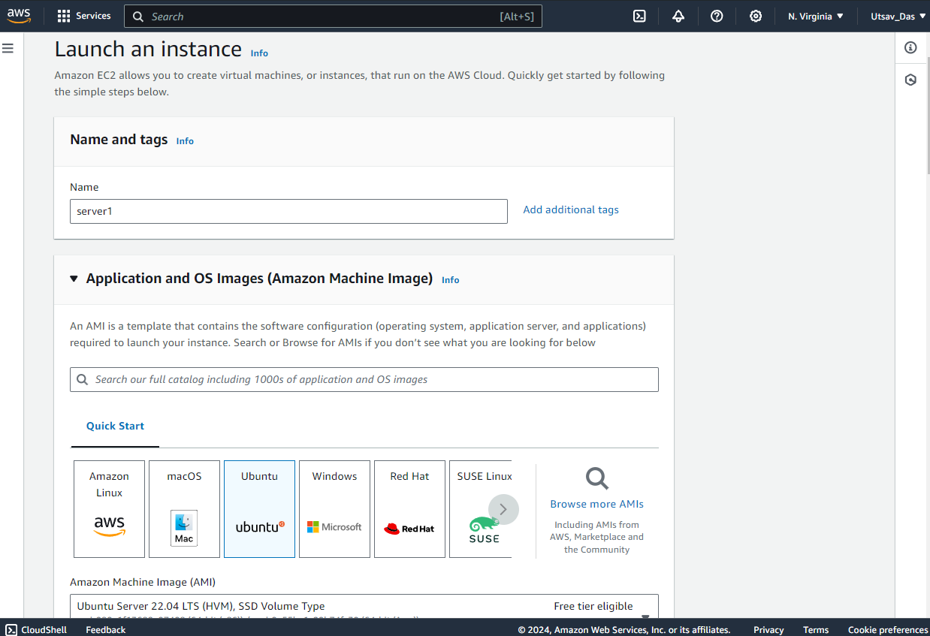

1. As we have pre-existing key pair, select the key pair from drop down menu.

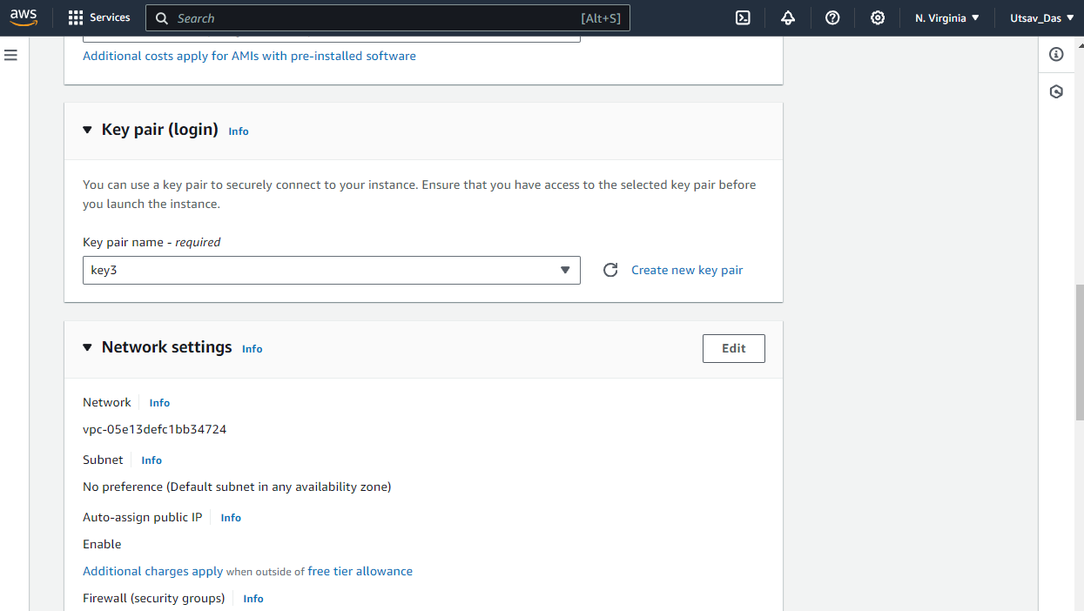

1. Select Create security group and click all checkboxes below it.

Then, click on Launch Instance.

1. Go to the Github project and then to index.html, where you can see 4000 in app.listen() which is port no that will be added to custom TCP.

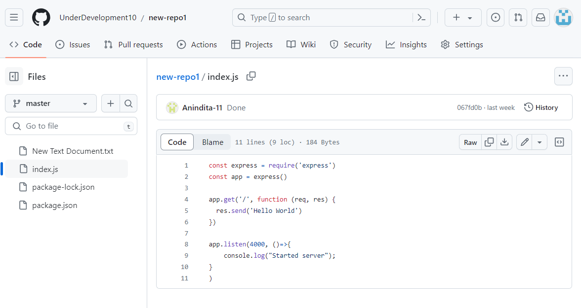

1. Go back to EC2 instances and select that instance newly made

and click on Security groups.

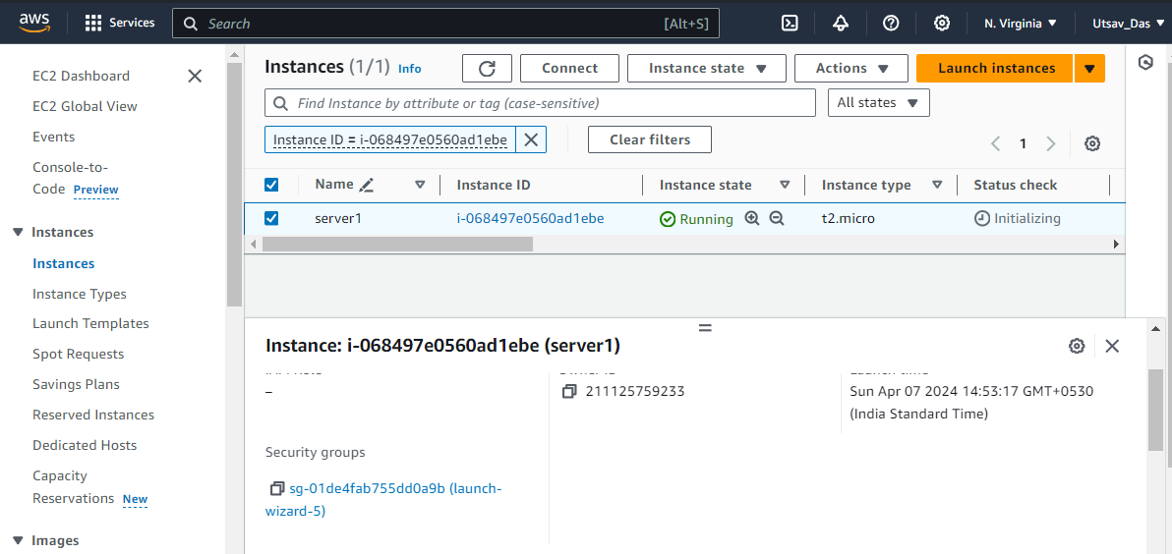

1. After in Inbound rules section click on Edit inbound rules.

1. In Inbound rules, click on Add rule select Custom TCP, give port range 4000 and select 0.0.0.0/0. Click on Save Rules.

1. Go back to EC2 recently created instance and copy the public IPv4 address.

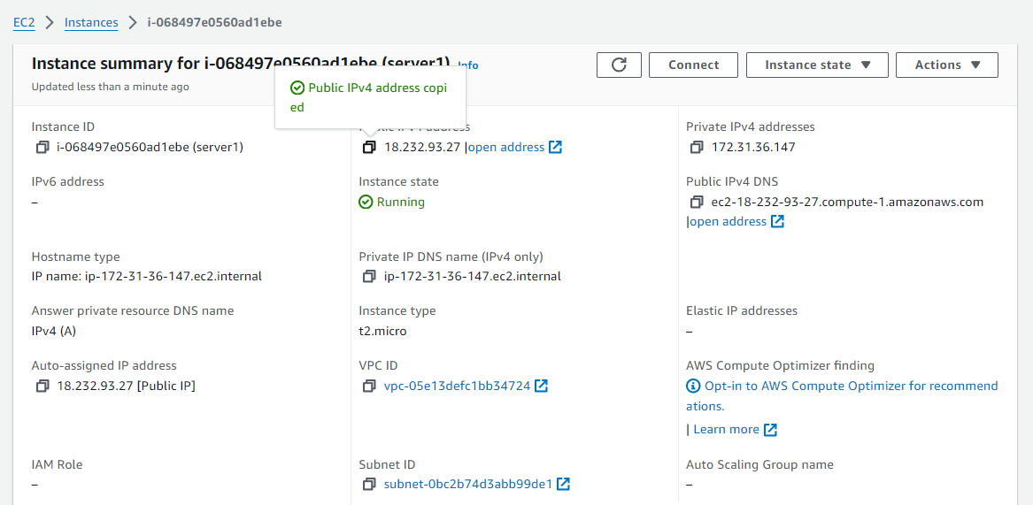

1. Open Bitvise SSH, go to Client key manager and import the key pair.

1. Paste that copied IPv4 public address in host and then click Login and click Accept and Save.

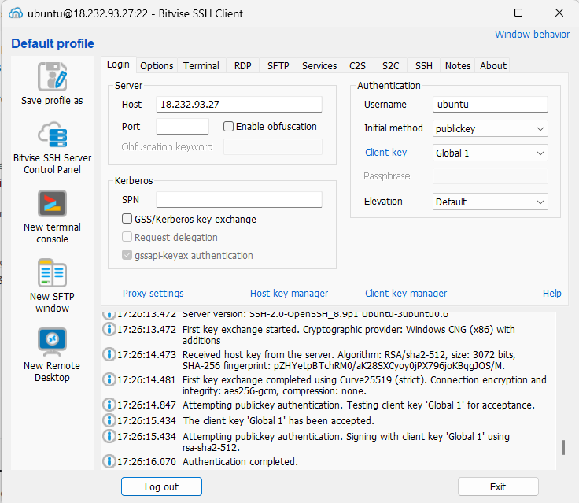

1. Open New Terminal Console and type command pwd to know current location.



1. Type command sudo apt-get update to fetch all packages.



1. Type sudo-apt upgrade to upgrade all outdated packages.



1. Type command sudo apt-get install nginx.



1. To execute JavaScript, we need to install NodeJS. Type command

curl –SL https://deb.nodesource.com/setup_16.x|sudo –E bash –



1. To install type sudo apt install nodejs.



1. Type node --version to see what version of NodeJS installed.



1. Now go back to GitHub and in Code copy HTTPS URL.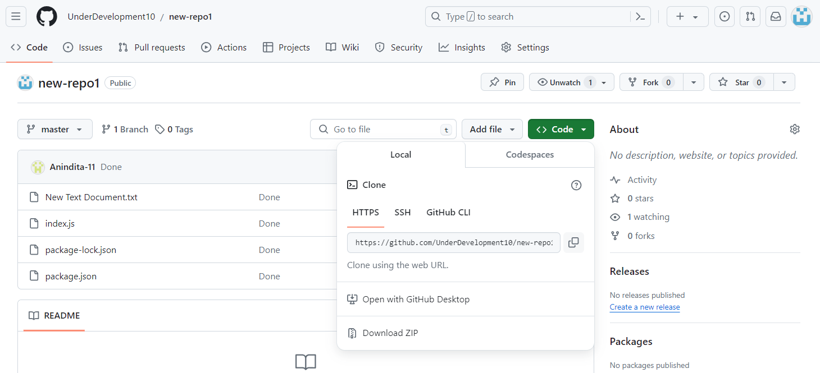
2. Type git clone and paste the URL to clone the repository.
3. Type ‘ls’ to see if project has been cloned or not. Then type command

cd (project name) to enter into the project and then type ls to see what files have been cloned.

1. Now, to execute node command we install node packet manager (npm). Type npm install.



1. Type node index.js



1. Copy public IPv4 address in EC2 instance and then paste it in another tab URL section.

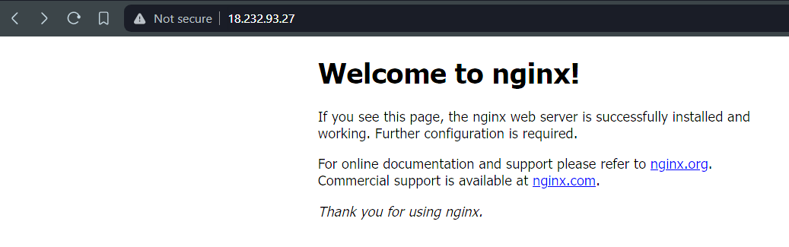

1. To add port number in URL at end write ‘:4000’.

1. At the end, to close server in new terminal press Ctrl+C to stop server and press Logout in Bitvise SSH window.